ADVISORY

TO : ALL SHIPPERS OF DOGS & CATS

SUBJECT : VETERINARY HEALTH CERTIFICATE & RABIES VACCINATION REQTS
____________________________________________________________________________________________________________
To avoid rejection and unnecessary delays in your application for ONE TIME local Shipping Permit, pls refer to BAI Memorandum dated June 02, 2020 for instruction and details of required Veterinary Health Certificate and Rabies Vaccination Records.
Pls click the INFORMATION TAB to view the document.
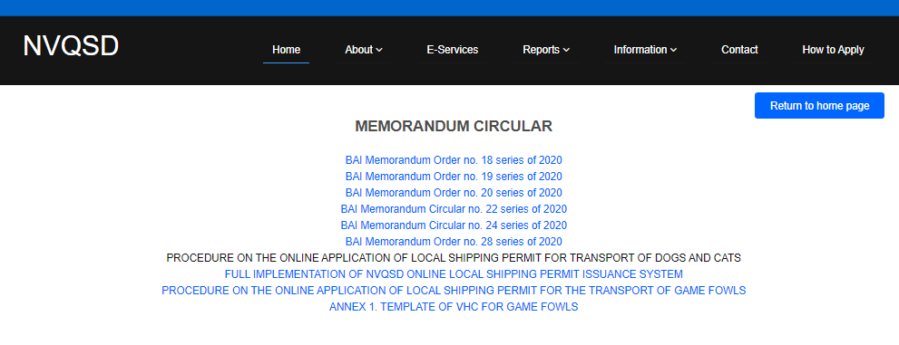

ANNEX 1. NEWCASTLE DISEASE VACCINATION PROGRAM FOR GAME FOWLS

A. General Recommended ND Vaccination Program
AGE | VACCINE TYPE | STRAIN | ROUTE
Day 3-7 | ND Live | B1B1 or any apathogenic enteric/respiratory strain | Intra-ocular  Intra-nasal
Day 14-17 | ND Live | La Sota | Intra-ocular  Intra-nasal
Day 28 | ND Killed | La Sota | Intra-muscular

B. Recommendation for Game fowls from High-risk areas
AGE | VACCINE TYPE | STRAIN | ROUTE
Day 1-3 | ND Live | B1B1 or any apathogenic enteric/respiratory strain | Intra-ocular  Intra-nasal
 | ND Killed or Vector ND | La Sota killed or rHVT+ND
Day 10-14 | ND Live | La Sota | Intra-ocular  Intra-nasal
Day 28 | ND Killed | La Sota | Intra-muscular  Can be optional if recombinant ND has been given at Day 1

